ADSUMUS – THE JOURNEY CONTINUES…
REFRESHER SUNDAY 2

HOMILY REFLECTION
We all have an experience of Parish life:
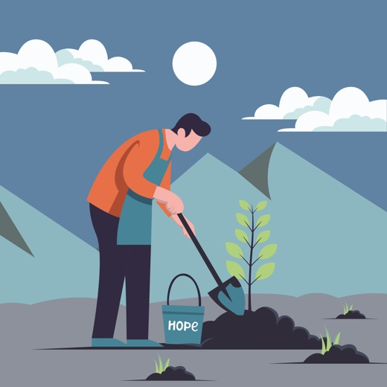
We know the work of the Parish Pastoral Council, Finance Committee, St Vincent de Paul Society, Youth Group, Liturgy Committee, RCIA etc.
Some of us are, or have been, involved in these ways. We have assisted the Parish Priest and Leadership Team in building the Parish.
Pope Francis urged all Christians to “Go out as disciples, generously offering your talents, creativity, wisdom and experience in order to bring the message of God’s tenderness and compassion to the entire human family.”
We are to value and recognise the dignity of each parishioner—their diverse and particular gifts—and so encourage them to contribute, as generously as they are able, to the life of our Parish.
This call, to be a Christian Community—to build connections and share our resources and talents is one that goes against our culture.

Today there seems to be a relentless movement towards greater individualism in virtually every area of life. We seem at times to be creating a culture where we simply desire to do ‘our own thing’. We can be so preoccupied with our ‘own inner worlds’ that we find it difficult to reach out to others in their ‘different’ worlds.
AI can make it easier to stay within our own world.
It can make our own reality seem like the only one that matters.
Our Baptism, the Sacraments and especially the Eucharist call us to join together as one, as we are vital members of the Community of the Church.
The ADSUMUS Process, in recent months, has been asking us to consider again this calling to reach outside of our busy worlds and know we have a role to play in building God’s Kingdom.

We have been asked two questions:
- What is a Parishioner and what is my part in this Parish Community?

Now consider a further question:
2) What is the true role of a Parish? or What is the VISION for our Parish?

Why commit so many resources—time, money, and talents—to the Parish?
The central focus of a Parish is our relationship with Jesus. Inspired by the Gospel, we are all tasked with building /growing this relationship – individually AND as a Team. (Individual prayer habits – retreats – prayer groups)

As a Christian Community it is vital that we care for each other in the spirit of Jesus: Seeking to know, respect, listen to each other. (Name Tag Weekends is a good start)
Our Sunday Eucharist nourishes our faith—through communal prayer and listening to the Scriptures – we are empowered to live this love through the week.
The Parish exists to continue the mission of the Church in the world—reaching out in practical care to all in need. (Outreach programs – the Parish’s St Vinnies Group)
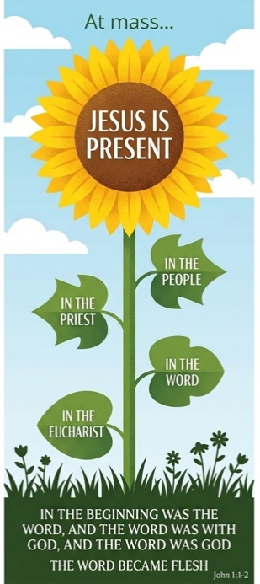
Christ is present in the Eucharist in 4 specific ways; ADSUMUS has encouraged us to pray using these 4 Presences:
- Before Mass – read and reflect on the Sunday Gospel (and Readings) in preparation.
- At Mass—be people of ‘Welcome’ and ‘Openness’—pray for those around us - speak to them; using their names if possible.
- Pray for the Priest—during Mass—esp. before the homily —that Christ will continually inspire him.
- When you receive Christ in the Eucharist—Pray that you will live with Christ through the ups and downs of the week, and pray also for other parishioners, that they too may know Christ’s presence.

Parish Renewal Team
450 Hay Street, Perth Ph: 6104 3699 Tues - Thurs
www.parishrenewal.com.au

Image references:

Unsplash. (2026, August 10). Illustration by DHUN RIFQI on Unsplash. https://unsplash.com/illustrations/person-with-smartphone-and-social-icons-AAGWfgNhwmc

Unsplash. (2025, February 20). Illustration by Gilang Fahmi on Unsplash. https://unsplash.com/illustrations/a-man-is-working-in-the-field-with-a-shovel-1rpkYV-Xc8w

Unsplash. (2025, February 17). Illustration by Round Icons on Unsplash. https://unsplash.com/illustrations/two-people-holding-hands-with-a-heart-in-the-middle-E2-Pk2_8Qdc

