ADSUMUS – THE JOURNEY CONTINUES….
REFRESHER SUNDAY 1

HOMILY REFLECTION
Our Parish continues the Adsumus Journey.
We have spent 10 weekends reflecting on the call each of us has received at our Baptism.


We have been born into a Church Community, led by the Holy Spirit and travelling together on a journey started by Jesus.

Founders of movements are typically – generous, visionary, bold and creative.

These are certainly some of the powerful traits we see in Jesus. The Church that grew after Jesus’ Ascension sought to keep these traits alive. Yet, it has not been easy.

The fundamental ADSUMUS question is:


We stressed the following:
- One who knows and loves Christ and builds their life on Christ’s
vision.
- One who talks of union, charity, forgiveness, peace, eternity …
- One devoted to building and living in a strong Christian
community and contributing as generously as is able and
possible.
- One who envisions a Church, faithful to the best of our tradition
- yet willing to create new ways to speak to new generations.
      - One who acts in solidarity with the needy, the poor, the
marginalised.
ADSUMUS has encouraged us to pray using the 4 presences of Christ in the Mass: -
- Before Mass – read the Sunday Gospel (and Readings) in preparation.
- At Mass – be people of ‘Welcome’ – pray for those around us - speak to them; using their names, if possible.
- Pray for the Priest – during Mass – especially before the homily.
- After Communion (The Eucharist) – pray that you will live with Christ during the ups and downs of the week: Also praying for other parishioners, that they will know Christ’s presence as well.

The Church as a ‘communion of communities’ is an ideal we strive for in every Parish with Christ at its centre.

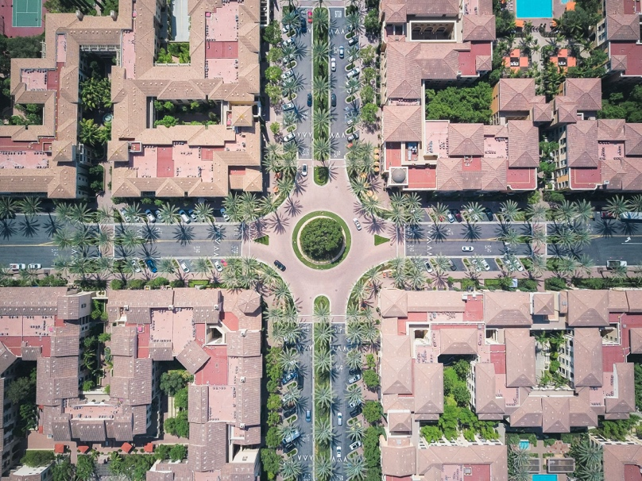
Although, all Parish ministries and groups working together, is a challenging project and takes time and patient work to establish, it is a vision that will enliven every parish, building strong individual Christians and powerful, dynamic parish Communities.

We want to create the most effective model that will enable our parish to function at its best – to bring the love and peace of Christ to our communities.

Parish Renewal Team
450 Hay Street, Perth
Ph: 6104 3699 Tues - Thurs
www.parishrenewal.com.au

Image References:

Best Leading The Way Photos. (n.d.). Retrieved 4 September 2026, from https://www.pexels.com/search/leading%20the%20way/

Best Love Photos. (n.d.). Retrieved 4 September 2026, from https://www.pexels.com/search/love/

Best Communities Photos. (n.d.). Retrieved 4 September 2026, from https://www.pexels.com/search/communities/

