ADSUMUS – STEP 3 WEEK 3

DATE: 20th Sunday in Ordinary Time 16th August 2026 Matt 15:22-28
THEME: The faith of a Canaanite woman
HOMILY REFLECTIONS
The Canaanite Woman needs help

- She calls out to Jesus, “Lord help me” –
- She asks and asks..
- Jesus reaches out to her … even when He is doubtful of her status … He looks beyond this …
- He sees her strong faith and her love for her daughter … He hears her cry ….
- Jesus responds with love and support.

People in the communities around our suburbs need help – often they cry out with their need for … faith … hope … security … physical needs …. Etc. In the name of Jesus, our parish has the role of reaching out to them.

- NOW - we are his arms and legs and heart
- NOW - we are to hear their cries
- NOW - we are to offer support in the name of Jesus.

These recent weeks, through the Adsumus Process, we have reflected on our baptismal call. We are reminded that baptism is essentially a call:
- to know Jesus …
- to live His love / His values ..
- to accept His call to work with our parish family … as a strong, united team …
- and together, use our talents/gifts to form a community capable of reaching out effectively to those in need.

There are many already working together in our parish in this way. Many individuals work on committees, ministries and groups carrying out fantastic work. For example:
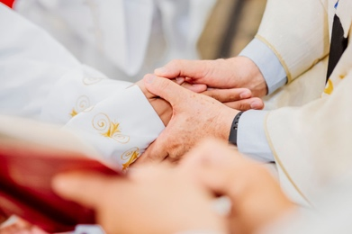
- The Parish Pastoral Council supports the Parish Priest in his leadership role as pastor…
- Our Parish Vincent de Paul Group …. Assists many needy families every week…
- The RCIA Group … has walked with and welcomed new Catholics
- Our Finance Committee …oversees parish money etc.

We thank them all for their committed work.

Today, our Parish Community is asking everyone to consider how you might offer your talents in the work of the Parish.

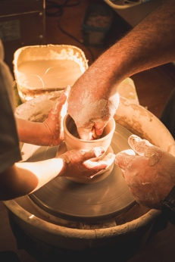
Community grows best when it makes room for the talents, opinions, hopes and dreams of members. We are from diverse cultures, backgrounds and social status yet, in Christ, we are united. When we all contribute our unique talents, we help shape an effective community that can change the world.
The parish community’s principal task is to bring Christ’s love and support to those in the parish and beyond. By working with one or more of these Parish Groups we are, together, Christ’s Church in this place.
Am I able to offer these talents to the mission of my parish community?

How can I prayerfully come to know (discern) my particular talents?
Optional Practical details:
- To assist with this task, you will be given a sheet explaining briefly the Parish Ministries and Groups active in our …… Parish.

- That sheet will also enable you to express an interest in one or more of these.

- Leaders / members of these groups will be available after Mass to answer any questions you may have before making a commitment.
Please consider this with your families during the week and bring the completed forms to Mass next week.

Parish Renewal Team
450 Hay Street, Perth
Ph: 6104 3699 Tues - Thurs
www.parishrenewal.com.au

Image References:

Antonucci, V. (2021, August 9). Person's hand reaching out to the sky [Photograph]. Pexels. https://www.pexels.com/photo/person-s-hand-reaching-out-to-the-sky-9089626/

Lach, R. (2021, September 6). Persons Holding Hands [Photograph]. Pexels. https://www.pexels.com/photo/persons-holding-hands-9463882/

Pexels. (2019, September 14). Priest holding the bride and groom [Photograph]. https://www.pexels.com/photo/priest-holding-the-bride-and-groom-2919738/

Sikunov, R. (2024, February 23). Man and woman crafting in workshop [Photograph]. Pexels. https://www.pexels.com/photo/man-and-woman-crafting-in-workshop-20368053/

