ADSUMUS – STEP 3 WEEK 2

DATE: 19th Sunday in Ordinary Time 9th August 2026 Matt 14:22-33
THEME: “Take courage, it is I. Do not be afraid”
HOMILY REFLECTIONS

This journey of renewal, Adsumus, is like a magnifying glass showing us a little more clearly that our Baptism

- Celebrates our intimate relationship with Jesus
- Reminds us that we are linked to one another
- And that we are united in Christ’s mission

In today’s Gospel we hear Jesus calling Peter and the disciples – in the boat, buffeted by the storm - to trust Him

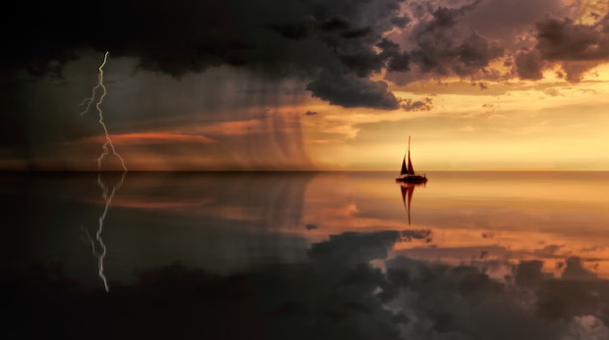
- The disciples set out together in a boat in the turbulent waters of a storm
- Peter steps out of the boat to face the storm
- He becomes focused on the wind, his own fear and his faith falters
- Jesus rescues him, returns to the boat, and the vessel sees out the storm

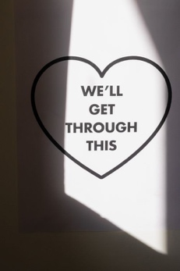
Through Peter’s experience of Jesus, we are given an image of what a faith community is called to
- Minds and hearts focused on Jesus
- Journeying together in community
- Riding out the storms around us
- Trusting in God’s abiding presence
- Supporting one another along the journey

To survive this journey – to follow Christ – to live and fulfil His mission we are called

- To be in relationship with Jesus
- To work and listen to one another
- To move in unison
- To share in the struggles life brings
- To bring His life and joy to all around us
How am I living as a parishioner?
How am I strengthening this parish community with my gifts and talents?

Parish Renewal Team
450 Hay Street, Perth
Ph: 6104 3699 Tues - Thurs
www.parishrenewal.com.au

Image References:

Mascaro, M. (2017, December 3). Person holding magnifying glass [Photograph]. Pexels. https://www.pexels.com/photo/person-holding-magnifying-glass-712786/

Plenio, J. (2018, May 28). Silhouette photography of boat on water during sunset [Photograph]. Pexels. https://www.pexels.com/photo/silhouette-photography-of-boat-on-water-during-sunset-1118874/

ROCKETMANN TEAM. (2021, September 8). Clenched Fists of People on top of One and Another [Photograph]. Pexels. https://www.pexels.com/photo/clenched-fists-of-people-on-top-of-one-and-another-9486935/

Zimmerman, P. (2020, September 13). Inspirational message about getting through together [Photograph]. Pexels. https://www.pexels.com/photo/inspirational-message-about-getting-through-together-4108166/

